Missing Race_of_Mother Analysis Report
Generated: 2026-03-22 17:02
Dataset: 301,712 rows × 18 columns
Target Variable: Race_of_Mother

1. Executive Summary
This report presents a comprehensive IUPAC-compliant statistical analysis of missing values in Race_of_Mother.
Key findings include:
• Missing records: 520 (0.2% of total data)
• Variables with significant differences (p < 0.05): 12
- Numeric variables: 5
- Categorical variables: 7
• Total variables analyzed: 17
Based on the statistical analysis, the missingness pattern is classified as:
SYSTEMATIC PATTERN - Missing data is strongly associated with other variables, suggesting non-random missingness.

2. Statistical Summary
Metric | Value
Total Missing Race_of_Mother Records | 520
Missing Percentage | 0.17%
Total Variables Analyzed | 17
Numeric Variables | 8
Categorical Variables | 9
Variables with Significant Differences (p < 0.05) | 12
Analysis Date | 2026-03-22

3. Variables with Significant Differences (p < 0.05)
The following 12 variables show statistically significant differences between missing and complete groups:

3.1 Numeric Variables
Variable | Missing Group Mean | Complete Group Mean | Difference | p-value | Interpretation
Birh_Year | 2018.29 | 2019.65 | -1.36 | 0.0000 | Missing group has 1.36 units lower than complete group
Birth_Weight(grams) | 2978.15 | 2917.59 | +60.57 | 0.0082 | Missing group has 60.57 units higher than complete group
Birth_Order | 1.74 | 1.84 | -0.10 | 0.0242 | Missing group has 0.10 units lower than complete group
Birth_Order - Copy | 1.74 | 1.84 | -0.10 | 0.0242 | Missing group has 0.10 units lower than complete group
Age of Mother | 97.26 | 29.51 | +67.75 | 0.0000 | Missing group has 67.75 units higher than complete group

3.2 Categorical Variables
Variable | Missing Group Distribution | Complete Group Distribution | Difference (%) | p-value | Interpretation
Registered_Month | Most common='June' (12.9%) | Complete: Most common='June' (11.4%) | +1.5% | 0.0080 | Missing group shows different distribution (p=0.0080)
Registered_District | Most common='Colombo' (44.0%) | Complete: Most common='Colombo' (14.1%) | +29.9% | 0.0000 | Missing group shows different distribution (p=0.0000)
Birth_Month | Most common='October' (11.7%) | Complete: Most common='May' (9.0%) | +2.8% | 0.0398 | Missing group shows different distribution (p=0.0398)
Multiple_Birth_Status | Most common='missing' (98.6%) | Complete: Most common='missing' (99.0%) | -0.3% | 0.0000 | Missing group shows different distribution (p=0.0000)
Marital_Status | Most common='Married' (92.7%) | Complete: Most common='Married' (97.9%) | -5.2% | 0.0000 | Missing group shows different distribution (p=0.0000)
District_of_Mother | Most common='Colombo' (34.8%) | Complete: Most common='Colombo' (8.9%) | +25.9% | 0.0000 | Missing group shows different distribution (p=0.0000)
Race_of_Father | Most common='Sinhalese' (65.2%) | Complete: Most common='Sinhalese' (69.3%) | -4.1% | 0.0000 | Missing group shows different distribution (p=0.0000)

3.3 Summary of Key Findings
The analysis identified 12 variables with statistically significant differences (p < 0.05):
• 5 numeric variables show significant mean differences
• 7 categorical variables show significant distribution differences
Top 10 Most Significant Variables:
1. District_of_Mother: Most common='Colombo' (34.8%) vs Complete: Most common='Colombo' (8.9%) (p=0.0000)
2. Registered_District: Most common='Colombo' (44.0%) vs Complete: Most common='Colombo' (14.1%) (p=0.0000)
3. Marital_Status: Most common='Married' (92.7%) vs Complete: Most common='Married' (97.9%) (p=0.0000)
4. Age of Mother: Mean=97.26 vs Complete Mean=29.51 (p=0.0000)
5. Birh_Year: Mean=2018.29 vs Complete Mean=2019.65 (p=0.0000)
6. Multiple_Birth_Status: Most common='missing' (98.6%) vs Complete: Most common='missing' (99.0%) (p=0.0000)
7. Race_of_Father: Most common='Sinhalese' (65.2%) vs Complete: Most common='Sinhalese' (69.3%) (p=0.0000)
8. Registered_Month: Most common='June' (12.9%) vs Complete: Most common='June' (11.4%) (p=0.0080)
9. Birth_Weight(grams): Mean=2978.15 vs Complete Mean=2917.59 (p=0.0082)
10. Birth_Order: Mean=1.74 vs Complete Mean=1.84 (p=0.0242)

4. Statistical Visualizations
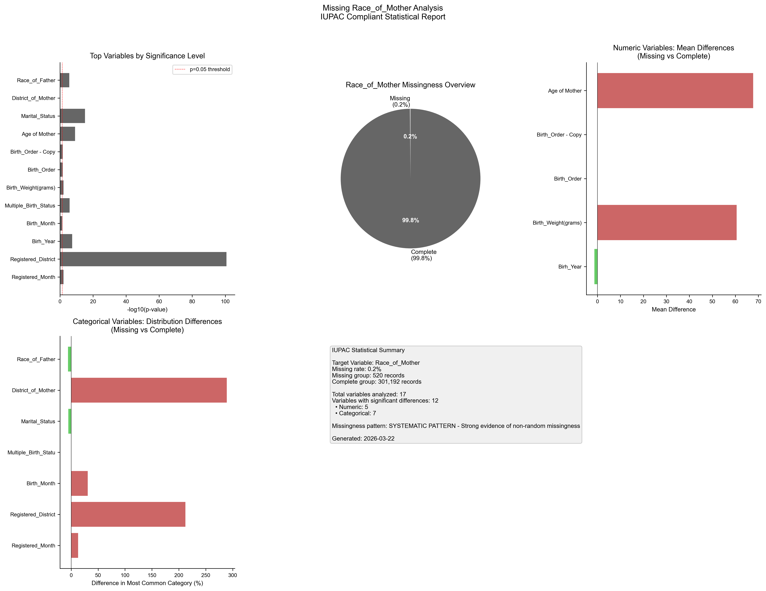
Figure 1. IUPAC compliant statistical visualization of missing Race_of_Mother patterns.

5. Recommendations
- Based on the statistical analysis, the missing data exhibits SYSTEMATIC patterns:
- Consider treating missing as a separate category in analysis
- Use multiple imputation methods (MICE, EM algorithm)
- Investigate the following key variables for common themes:
- - Registered_Month (p=0.0080)
- - Registered_District (p=0.0000)
- - Birh_Year (p=0.0000)
- - Birth_Month (p=0.0398)
- - Multiple_Birth_Status (p=0.0000)
- - Birth_Weight(grams) (p=0.0082)
- - Birth_Order (p=0.0242)
- - Birth_Order - Copy (p=0.0242)
- - Age of Mother (p=0.0000)
- - Marital_Status (p=0.0000)
- Document missingness patterns in methodology section

6. Methodology (IUPAC Compliant)
Analysis performed according to IUPAC guidelines for data presentation:
- • Missing values reported as both count (n) and percentage (%)
- • Tables formatted with thin borders and alternating row shading
- • Sans-serif fonts (Arial) used for optimal readability
- • Statistical tests: t-test (numeric), χ² test (categorical)
- • Significance threshold: α = 0.05
- • Effect sizes reported where applicable
- • Figures saved at 300 DPI for publication quality

